PRESS RELEASE
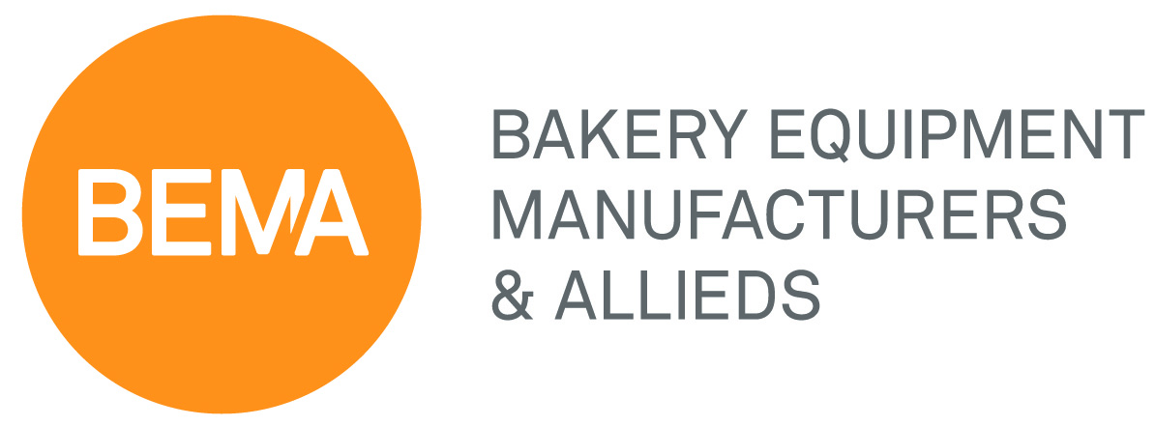

For Immediate Release July 25, 2017

BEMA Elects 2017-2018 Chairman and Board of Directors

OVERLAND PARK, KS - BEMA elected new members to its executive committee and board of directors at its 2017 Convention. Don Osborne, Team Leader, Intralox, was elected chairman of the board of directors.

Don Osborne joined Intralox 15 years ago and has spent the last six years overseas managing bakery and other food-related territories for Intralox in China, Japan and Korea. He has 40-plus years of experience in the baking industry and got his start on the bakery side. Osborne was elected to the BEMA board of directors in 2010 and has served as the chairman of the scholarship and membership committees and as co-chairman of the convention and programs committee. He joined the executive committee in 2014.

“The industry has provided so much for me and my family that it is an honor to give back some of my time, talents and resources,” says Osborne who is adopting a theme of ‘giving back’ this year. With Osborne as chairman for its 100th anniversary year, BEMA’s tradition of giving back throughout its history and its investments in the future will be prominent in the planned celebrations.

The membership elected the following executive committee: Don Osborne (Intralox), Chairman; Paul Lattan (Sosland Publishing), 1st Vice-Chairman; Mark Hotze (Corbion), 2nd Vice-Chairman, Rick Hoskins (Colborne Foodbotics), 3rd Vice Chairman and Allen Wright (Hansaloy), Immediate Past Chairman.

Mike Pierce, President, The Austin Company; Mark Podl, CEO, Doran Scales and Jason Ward, CEO, AMF Bakery Systems were elected to their first term on BEMA’s board of directors. Joining the board as BEMA’s representative on the IBIE Committee, and serving as the vice-chairman for IBIE 2019, is Dennis Gunnell (Formost Fuji).

BEMA’s current directors also include Tim Cook (Shick Solutions), Mike Day (Banner-Day), Mike Gude (Sosland Publishing), Jay Hardy (AB Mauri), Clay Miller (Burford Corp.), Patrice Painchaud (Rexfab, Inc.), and Jim Warren (Reading Bakery Systems).

BEMA, bakery equipment manufacturers and allieds, is celebrating its 100th year of serving the industry as an international, not-for-profit trade association representing leading bakery and food suppliers. BEMA creates authentic connections that improve its members’ businesses and the baking industry. Its members utilize the value they gain through BEMA networking and educational events to provide their customers with the most effective, innovative solutions in baking.

###

Photo attached to the email containing this press release:

BEMA Chairman, Don Osborne, Team Leader, Intralox

