Belt Conveyor Standard of Construction  The belt conveyor standard of construction contains information on the best sanitary design practices for design and fabrication of conveyor equipment in dry production, wet production, or dairy production environments. | Table of Contents  1. Introduction  2. Dry Production Environments  3. Wet Production Environments  4. Sensitive Production Environments  5. General Conveyor Construction  6. Reference Documents  7. Revision Summaries

Introduction
This document provides an overview of conveyor design/build best practices to minimize the sanitation labor and risk of food contamination for conveyors transporting open food product. It is divided into sections for dry clean, wet clean, and dairy/meat production environments, and finally general conveyor construction. The intention is to document a series of best practices that can be easily shared within General Mills and used as part of the equipment specification for external equipment vendors.

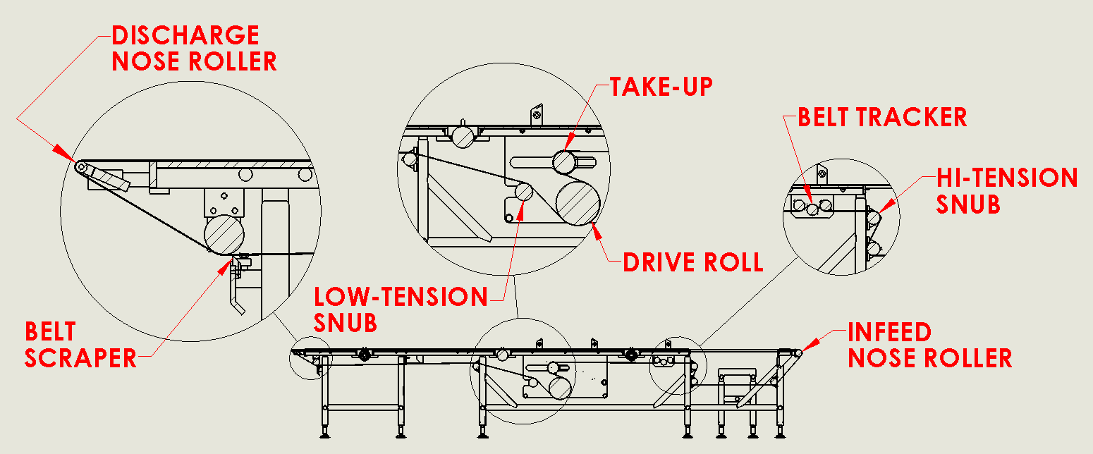
Figure 1 - Generic Conveyor layout

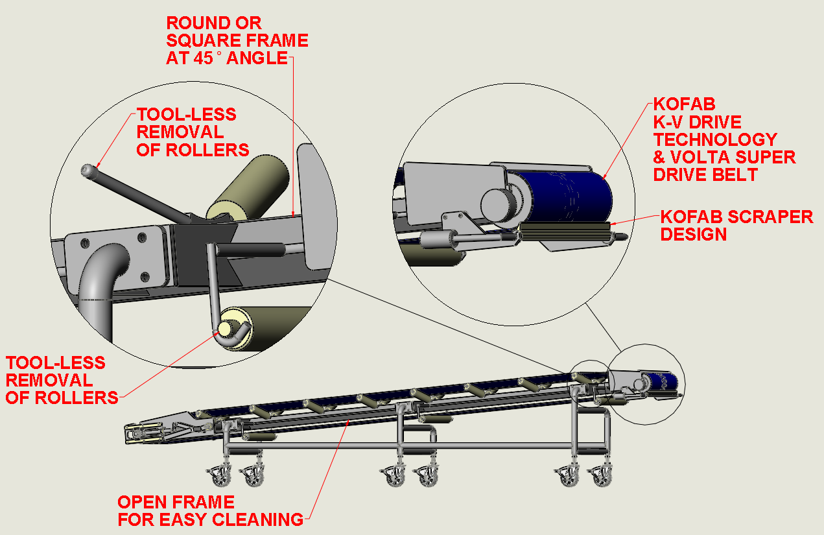
Figure 2 – Sanitary conveyor attributes for PFI references please contact them at (https://www.pfi-global.com/ or 1-515-295-7265)

Definitions

Conveyor: Equipment in which a belt(s) is used to convey products at a controlled rate.

Corrosion Resistant: the ability of a material to resist deterioration caused by exposure to an environment.

Pulleys: Devises used to drive and return the conveying belt

Rollers: Devises used to support and guide the conveying belt.

Inspectable: Designed, fabricated, and installed to make surfaces accessible for quick close visual observation.

Product Contact Surfaces: Surfaces exposed to the product itself and surfaces on which splashing, dropping, or draining may occur. This includes surfaces that may be drawn into the product zone.

Metal for product contact surfaces shall be of AISI 300 series stainless steel unless specifically agreed to by GMI.

Plastic for product contact surfaces shall be of an FDA approved material. Attributes such as metal detectable, X-ray, antimicrobial are acceptable and may also be required depending on application.

Ceramics are not an acceptable food contact surface unless specifically agreed to by GMI.

Adhesives shall be nontoxic and comply with 21 CFR 175 – Indirect Food Additives: Adhesive and Components of Coatings. (Refer to section 6, Reference No. 7)

Non-Product Contact Surfaces: Surfaces not exposed to the product itself and surfaces on which there is no exposure to splashing, dropping, and draining.

All non-product contact surfaces shall be cleanable, non-absorbent, durable, and corrosion resistant. Coated surfaces shall adhere and be free of chipping or flaking.

Bead Blasting: A surface treatment in which an abrasive material is blown against the surface to achieve a uniform finish.

Conveyor Selection Guidance

This section will help to select the best conveyor belt style for your application and to avoid high sanitation costs.

Conveyor types

Continuous belt conveyor (Volta®, Habasit®, Siegling®, and FN Sheppard)
    - Easy to clean
    - Fully wet washable, but dry cleaning can be an option depending on the soil needed to be removed
    - Easy belt removal
    - You can scrape the belt surface
    - No tracking required with some belt technologies
    - Really small pulley diameter and precise belt transitions possible
    - Gentle on product
    - Needs tension/take-up
    - Maintains positive product orientation
    - Does not require large drive section
    - Drum motors are an option
    - Can be portable
    - Linear belt. 90-degree conveyor option is available but will require additional labor to clean.
    - Long belts can be difficult to clean and handle. Belts that are too large or heavier than 1 employee can handle will require additional labor, and a custom rack for cleaning/storage
    - Edge corrugation guides to hold in product will significantly increase the surface area/complexity to clean and therefor increase in labor will be needed
    - Foreign material risk of broken plastic pieces due to improper set up and mishandling. Regular inspection for damage and wear needs to be addressed as part of the inspection and maintenance program

Cleated belt conveyor
    - Easy to clean
    - Fully wet washable, but dry cleaning can be an option depending on the soil needed to be removed
    - Easy belt removal details
    - No tracking required with some belt technologies
    - Gentle on product
    - Needs tension/take-up
    - Does not require large drive section
    - Drum motors are an option
    - Can be portable
    - No conveyor turns, linear belt only
    - Long belts can be difficult to clean and handle. Belts that are too large or heavier than 1 employee can handle will require additional labor, and a custom rack for cleaning/storage
    - You cannot scrape the belt
    - Edge corrugation guides to hold in product will significantly increase the surface area/complexity to clean and therefor increase in labor will be needed
    - Significantly increases the surface area and could be difficult to dry clean
    - Metal cleats can lead to hand injuries
    - Foreign material risk of broken pieces due to improper set up and mishandling. Regular inspection for damage and wear needs to be addressed as part of the inspection and maintenance program

Modular plastic belt conveyor (Intralox, Rexnord)
    - Cheap
    - Fully wet washable
    - No tracking issues
    - Open surface for air movement/heat exchange applications
    - Gentle on product
    - Zero-tension belt (no pneumatic take-up required)
    - Does not require large drive section
    - Drum motors are an option
    - Can be portable
    - Conveyor turns
    - Larger pulley diameters required
    - Somewhat maintain product orientation
    - Very time-consuming cleaning process. 2x the surface to clean, in addition to the complexity to clean and inaccessibility to the interfaces of each of the hinge points and pins. Very difficult to validate to microbial cleaning standards.
    - Foreign material risk of broken plastic pieces due to improper set up and mishandling. Regular inspection for damage and wear needs to be addressed as part of the inspection and maintenance program

Dry Production Environments

- Dry Clean – the physical removal of material by manual means. Use of water or detergents is not permitted. Acceptable methods of dry cleaning include the following: brushing, scraping, vacuuming, low moisture sanitizing wipes and minimal compressed air (by exception ONLY). Dry cleaning may be used for low Aw products (< 0.6) including liquid ingredients (e.g. oils, HFCS, etc.)
  - Meets or exceeds the following criteria (as defined by the Sanitation Center of Excellence):
    - all surfaces can be cleaned and maintained for GMI quality indicator microorganism thresholds
    - zero pathogens
    - GMI thresholds for allergens via analytical sampling
    - prevents the harborage and growth of pests
    - meets all regulatory requirements
    - prevents quality/sensory issues
- “Dry chemical spray cleaning” to acceptable methods of drying cleaning
- Dry cleaning may be used for a variety of soils including low Aw (water activity) liquid ingredients

Specific Fabrication and Weld Quality

Conveyors should be constructed of AISI 300 series stainless tube. All welding to be continuous, smooth, flush, and finish being equivalent to 52 µin Rα. In some cases, painted frames may be used with prior approval from GMI. Painted surfaces shall not be over product areas.

Motors and gearboxes can be painted. (Approved manufactures can be found in Schedule W Machine Component Guideline)

Intralox, and Rexnord belt material is acceptable

Multi piece roller is acceptable

Lap joints are acceptable, so stand-offs are not a requirement in this environment. (Example: Bolted scrapers, bearings)

Exposed threads are acceptable

Electrical and controls design should be in accordance to General Mills OEM Electrical & Controls Guidelines, and Schedule Z conformance worksheet should be completed with all projects)

Bearings are preferred to be of AISI 300 series stainless, but in some instances painted bearings can be used with prior approval from GMI. (Approved manufactures can be found in Schedule W Machine Component Guideline)

Wet Production Environments
Wet production environments are defined as those that have either; wet product in contact with the surface of the conveyor or use wet wash sanitation procedures to clean and sanitize the conveyor at the end of the run.
- Wet Clean– the physical removal of material and subsequent sanitizing with the aid of chemicals (cleaners and sanitizers) and water. Acceptable methods include the following: bucket and brush, foaming, CIP, COP, and automated washers. Wet cleaning may be used when the debris material has an Aw =/> 0.6 or material that can't be adequately removed with dry methods (e.g. sticky)
  - Wet clean methods
    - Controlled wet cleaning - very controlled use of water and chemicals (spot cleaning)
    - Flood cleaning (hosing/foaming)
  - A wet product zone meets or exceeds the following criteria (as defined by the General Mills Sanitation Center of Excellence):
    - all surfaces can be accessed, cleaned, sanitized, and inspected for:
      - quality indicator microorganism thresholds
      - zero pathogens
      - GMI thresholds for allergens via analytical sampling
      - prevents the harborage and growth of pests
      - meets all regulatory requirements
      - prevents quality/sensory issues
  - Wet cleaning may be used when dry cleaning methods are inadequate to remove the soil

Specific Fabrication and Weld Quality

Conveyors shall be constructed of AISI 300 series stainless tube. All welding to be continuous, smooth, flush, and finish being equivalent to 42 µin Rα.

Motors and gearboxes can be painted and must be wash-down rated. (Approved manufactures can be found in Schedule W Machine Component Guideline)

Multi piece roller is not acceptable, shall be fully welded

Lap joints are not acceptable, see section 5.2 Stand-offs

Exposed threads should be avoided unless no other means of attachment is available and approved by GMI. When nut joints are used they shall be designed with acorn nuts to cover exposed threads.

Approved belting manufacturers would be Volta®, Habasit®, Siegling®, and FN Sheppard. Intralox® and Rexnord® belting is not acceptable, unless GMI approved. Thermolace or other hygienic lacing are options to help facilitate removal and cleaning.

Electrical and controls design should be in accordance to General Mills OEM Electrical & Controls Guidelines, and Schedule Z conformance worksheet should be completed with all projects)

Bearings shall be of AISI 300 series stainless. (Approved manufactures can be found in Schedule W Machine Component Guideline)

Threads

Adjustable joints using threads can be covered by means of an O-ring and be compressed by means of a positive stop. The sealed surface will be partially exposed for cleaning and inspection creating a crevice free joint without leaving the O-ring unsupported. (See Fig. 3 & 4) (Refer to section 6, Reference No. 1) Radii in Retaining grooves for O-rings refer to Table 2 below. (Refer to section 6, Reference No. 10 & 11)

Table 2 – Radii in Retaining grooves for O-rings
O-Ring Cross Section, Nominal (AS 568) | O-Ring Cross Section, Actual (AS 568) | O-Ring Cross Section, Actual (ISO 568) | Minimum Groove Radius
1/16” | 0.070” | 1.80 mm | 0.016” [0.41 mm]
3/32” | 0.103” | 2.65 mm | 0.031” [0.79 mm]
1/8” | 0.139” | 3.55 mm | 0.031” [0.79 mm]
3/16” | 0.210” | 5.30 mm | 0.062” [1.58 mm]
1/4" | 0.275” | 7.00 mm | 0.094” [2.39 mm]

O-rings exposed to cleaning chemicals etc. shall be of compatible material.
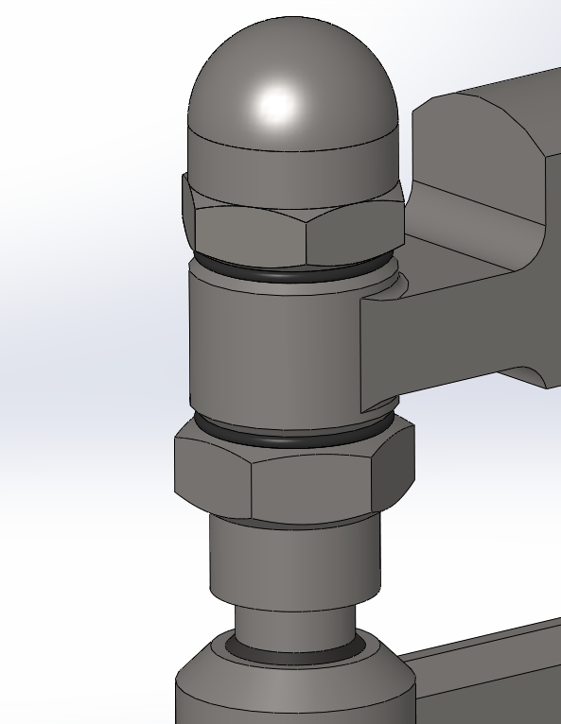
Figure 3
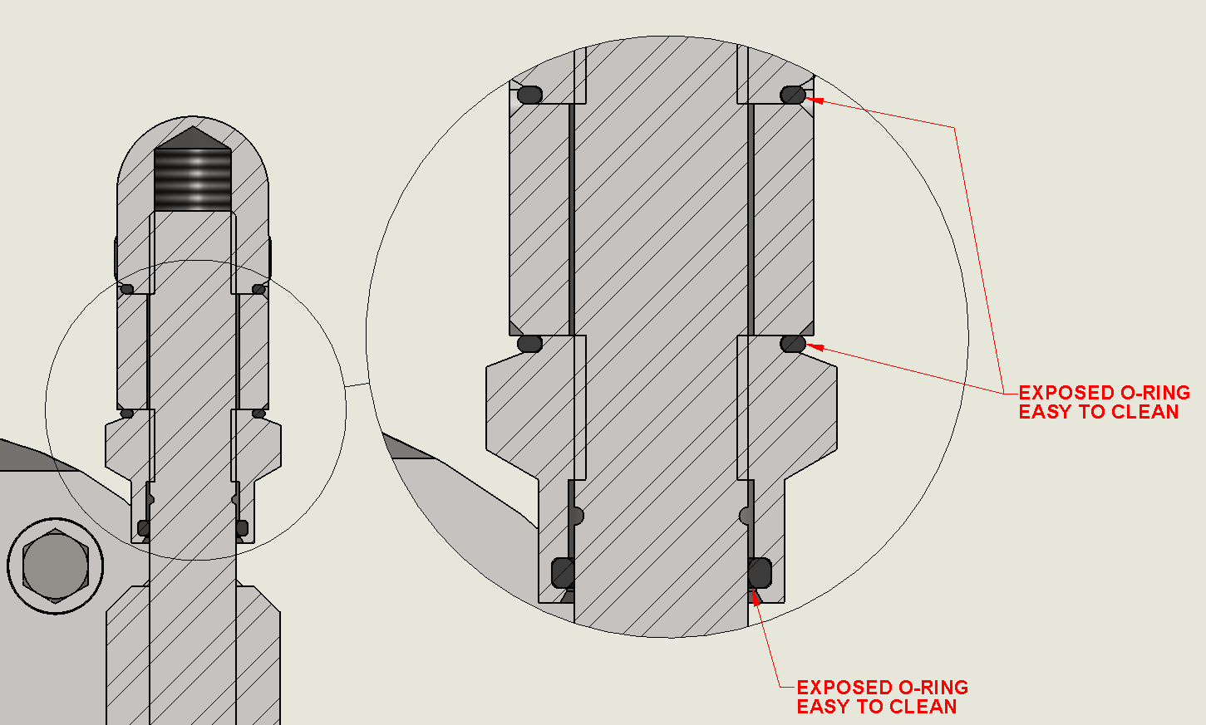
Figure 4

Sensitive Production Environments

Specific Fabrication and Weld Quality

Conveyors shall be constructed of AISI 300 series stainless tube. All welding to be continuous, smooth, and flush, all surface finishes being equivalent to 32 µin Rα. All welds must be GTAW (TIG). (Refer to section 6, Reference No. 3)

Enclosed threads as shown in section 5.5 are acceptable in a dairy environment but must conform to the 3-A Sanitary Standard Number 75.01 sections E1.7 & E1.9.1.1.1 (Refer to section 6, Reference No. 3).

Motors and gearboxes shall be stainless and shall be wash-down rated. (Approved manufactures can be found in Schedule W Machine Component Guideline)

Multi piece roller is not acceptable, shall be fully welded

Lap joints are not acceptable, see section 5.2 Stand-offs

Approved belting manufacturers would be Volta®, Habasit®, Siegling®, and FN Sheppard. Intralox® and Rexnord® belting is not acceptable, unless with prior approval from GMI. Thermolace or other hygienic lacing are options to help facilitate removal and cleaning.

Electrical and controls design should be in accordance to General Mills OEM Electrical & Controls Guidelines, and Schedule Z conformance worksheet should be completed with all projects)

Bearings shall be of AISI 300 series stainless. (Approved manufactures can be found in Schedule W Machine Component Guideline)

General Conveyor Construction

General Fabrication and Weld Quality

Conveyors shall be designed and fabricated so all product contact surfaces are readily accessible and inspectable either when in an installation position or when removed.

All surfaces shall also be designed for ease of cleaning and should be free of open seams, gaps, pockets, crevices, and inaccessible spaces where product, dust, or liquids may collect. (Refer to section 6, Reference No. 1)

The weld joint shall be designed so that the finishing operation does not weaken the integrity of the weld and the weld profile shall conform to acceptable weld profiles as noted in (AWS) American Welding Standards D1.1 Acceptable and Unacceptable Weld Profiles. (Refer to section 6, Reference No. 1 & 9) (See Fig. 5)

All welds should be designed so that they are accessible to finishing operations. (Refer to section 6, Reference No. 1 & 9)

All welds in product contact areas shall be free from defects and conform to regulatory standards, or application needs. Defects include:

Poor weld profile

Excessive undercut

Porosity

Slag inclusions / splatter

Tungsten inclusions

Non-conformance to welding symbols and notes

Cracks or voids

Unacceptable weld joint finish

Poor blending of weld bead starts and stops

Poor blending and tying the ends of welds around corners
Table 1
 | General Mills Standard Finishes Table
 | Sheet |  | No. |  | Description |  | Grit | Ra
 | Unfinished (As Rolled) |  | 1 |  | Rough dull finish that results from hot rolling to the specified thickness, followed by annealing and descaling. |  | N/A | N/A
 |  |  | 2D |  | (D) Dull cold rolled finish, followed by annealing and descaling, and a final pass through unpolished rolls. This finish is used where appearance is of no concern. |  | N/A | N/A
 |  |  | 2B |  | (B) Bright cold rolled finish with same process as 2D, except that the annealed and descaled sheet receives another pass through polishing rolls. |  | N/A | TYP 10-20
 | Finished (Polished) |  | 3 |  | Intermediate polished surface obtained by finishing with a 100-120 grit abrasive. This finish is generally used where a semi-polished finish is required. |  | 100-120 | 42-52
 |  |  | 4 |  | Polished surface obtained by finishing with a 120-150 grit abrasive, following initial grinding with coarser abrasives. This is a general purpose bright finish with a visible "grain" that prevents a mirror-like reflection. |  | 120-150 | 32-42
 |  |  | 7 |  | Reflective surface obtained by buffing a polished surface, but not to the extent of removing the visible "grain" or scratch pattern. |  | 180 | 30
 |  |  | 8 |  | Highly reflective surface obtained by extensively buffing a polished surface until all scratch patterns are removed to create a mirror-like finish. |  | 240 | 15

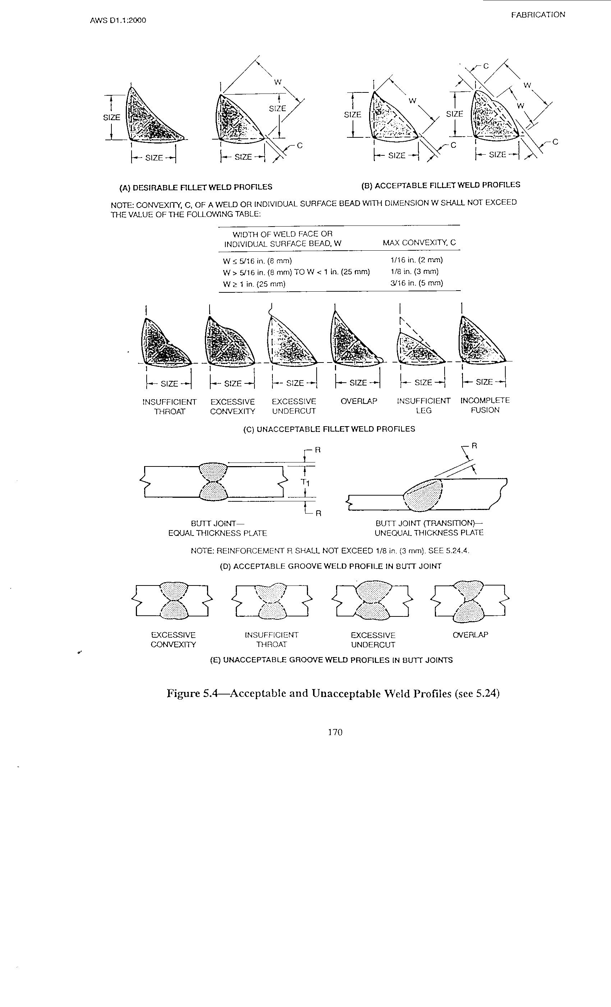
Figure 5 - Weld Profiles per AWS D1.1:2000

When possible, square tube should be rotated at 45 degrees to reduce horizontal surfaces. (See Fig. 6)

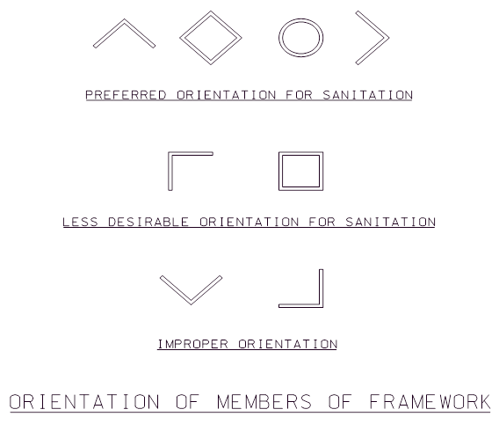
Figure 6 - (Refer to section 6, Reference No. 1).

Sanitary tubing shall be welded in accordance with either AWS/ANSID18.1 or EHEDG Doc.9 (Refer to section 6, Reference No. 4).

Absolutely NO tube penetrations are allowed. Options are to use welding studs, tapped standoffs (See section 3.6), or sleeve (See Fig. 7). Sleeves must be permanently sealed and conform to weld standards mentioned above.

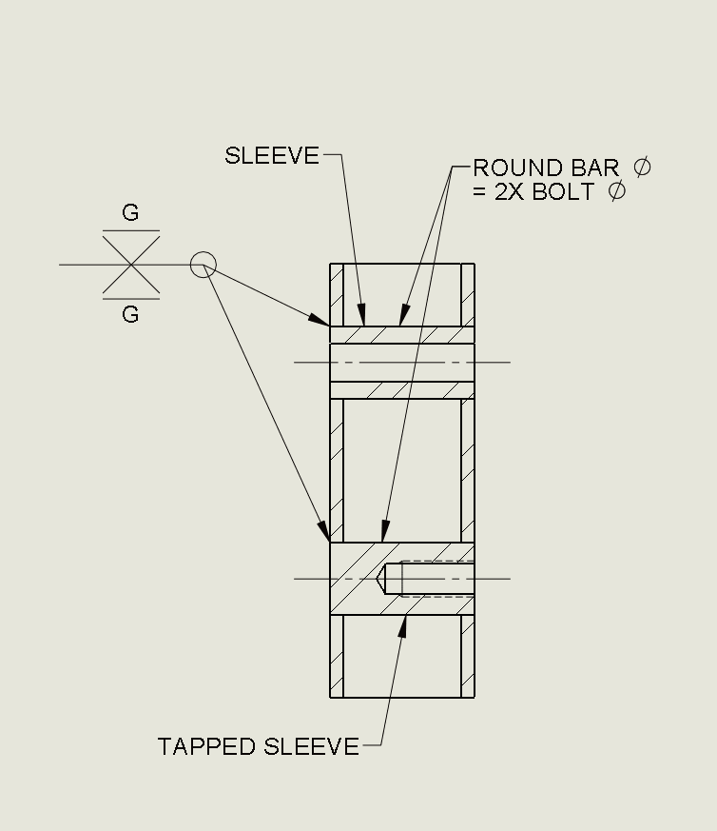

Figure 7 - Section view of sleeved penetration in tube

All edges and corners shall be deburred and rounded smooth. (Refer to section 6, Reference No. 1)

All open ends of tubing shall be closed with a continuously welded cap. (Refer to section 6, Reference No. 1)

Stand-offs

Any components or fabricated parts attached to the conveyor should be either continuously welded in place or attached with stand-offs for Wet and Sensitive environments.

Stand-off diameter shall be 2X larger than the bolt size and be a minimum of ½” long. (See Fig. 8, 9, & 10)
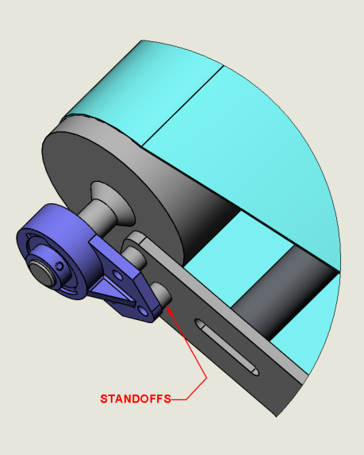
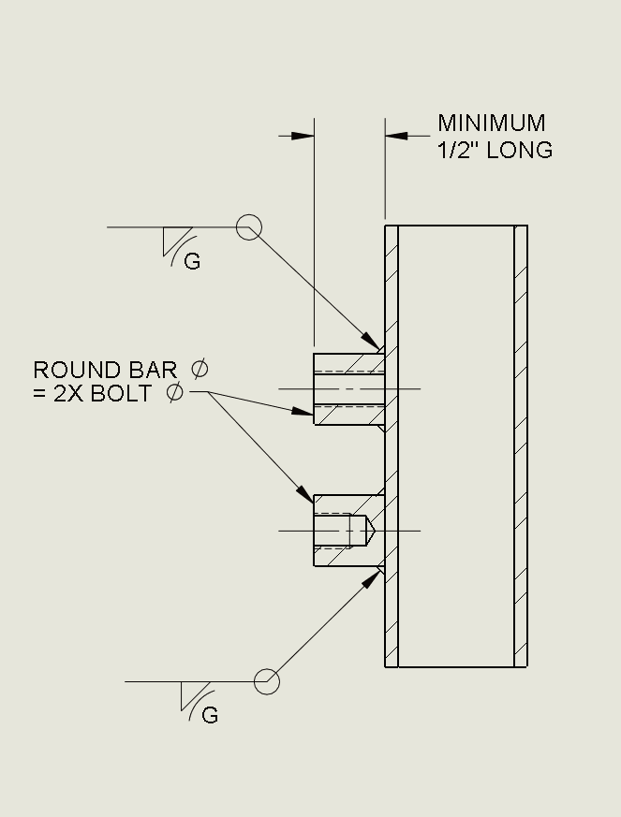
Figure 8
Figure 9
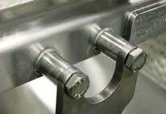
Figure 10 – Stand-off example

Unnecessary holes shall be avoided as they create harborage points and micro risk.

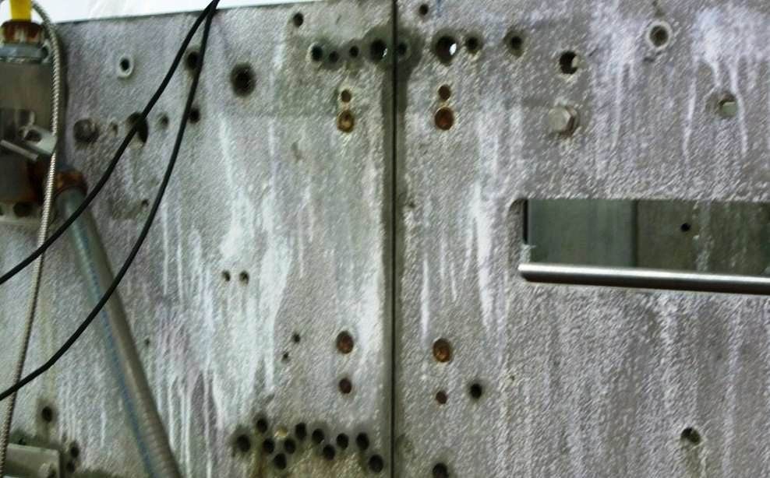
Figure 11 – Example of what is not acceptable

Guarding

Safety guarding shall follow the General Mills Safety Guard Design Standard document. (Refer to section 6, Reference No. 8)

Name or Serial Plates

A manufacturer nameplate shall be mounted on all equipment. Nameplates shall list manufacturer name, equipment model and/or serial number, and date of fabrication. It is recommended that the nameplates also list gross weight and purchase order information. Nameplates shall be constructed of Series 300 stainless steel, laser engraved, or stamped with a minimum of 3/16” high characters, and continuously welded in a readily accessible area. (Refer to section 6, Reference No. 1)

Adhesive labels shall not be used in or above any product contact area. Labels specifically related to safety or equipment operation may be used away from product contact areas. (Refer to section 6, Reference No. 1)

Non-informational labels, such as “Made in the USA” shall not be attached to the equipment. (Refer to section 6, Reference No. 1)

Pulleys and Rollers

Lugged conveyor drive rolls should be free of 90-degree corners and shall use radius edges on the roll surface as shown in Fig. 12 for easy cleaning unless approved by GMI.

Pulleys and rollers will be solid or if hollow is permanently sealed.

Sleeved rollers are also acceptable with FDA approved sleeve material.

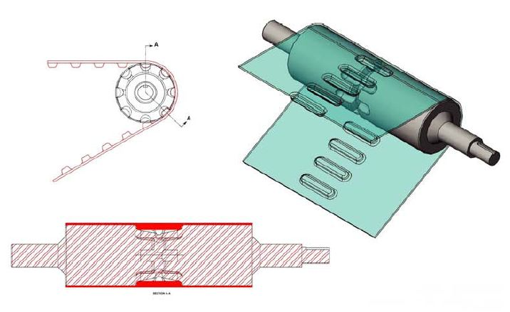
Figure 12 – Volta belt with a solid roller shown above and is also available in motorized pulleys from PFI (https://www.pfi-global.com/ 1-515-295-7265)

Belt Scrapers

Conveyor belt scrapers should be designed for easy, tool-less removal of the scraper blade to all exposed surface areas, except where noted in 2.1.5. Sani-Scraper shown below (fig. 13 & 14) can be purchased as a complete package from PFI (https://www.pfi-global.com/ or 1-515-295-7265). It has a replaceable Magnethane UHMW blade, with metal detectable and antimicrobial properties. Other equivalent tool-less designs are acceptable.

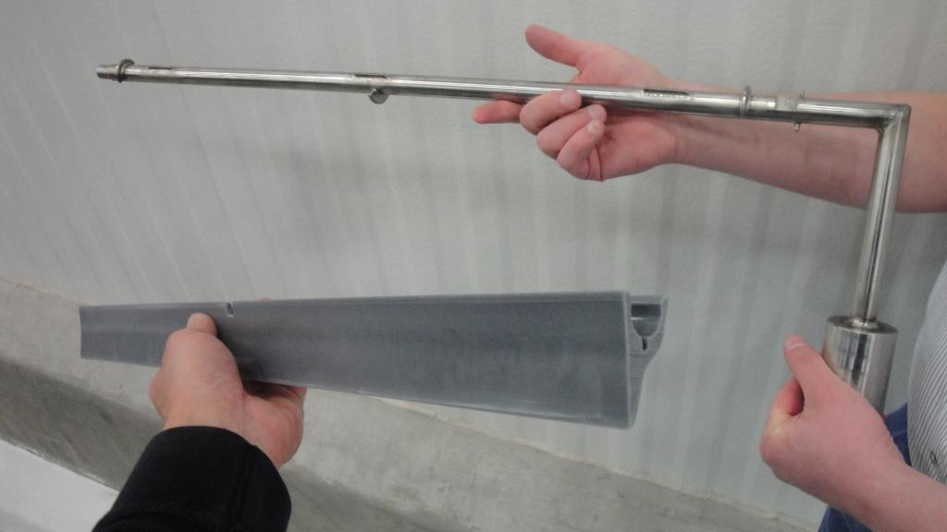
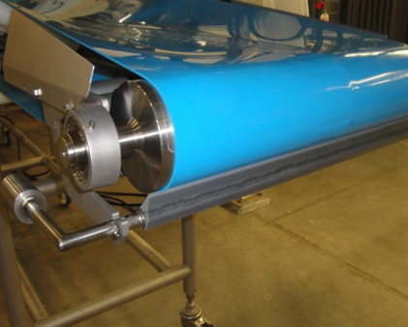
Figure 13 – Sani-Scraper components
Figure 14 - Sani-Scraper mounted on conveyor

Take-ups

Take up should be sufficient to fully tension the belt and additionally provide access to clean, inspect, and sanitize the inside of the conveyor with a belt lift mechanism or to remove the belt completely.

Take-up exposed threads shall be avoided unless approved by GMI. Sanitary sealed threads can be obtained by means of an O-ring. (Refer to section 3.2) also (see Fig. 17 & 18)
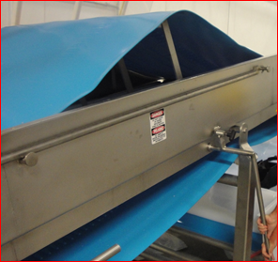

Figure 15 –Quick release assists cleaning and frame inspection

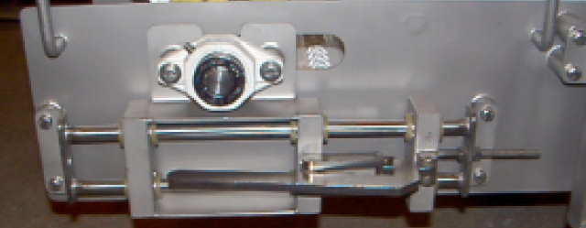
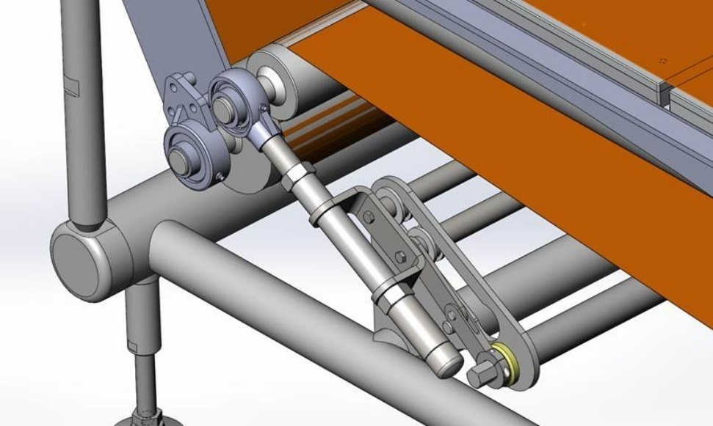
Figure 16 – This quick release take-up can be used when belt is not required to be removed for cleaning
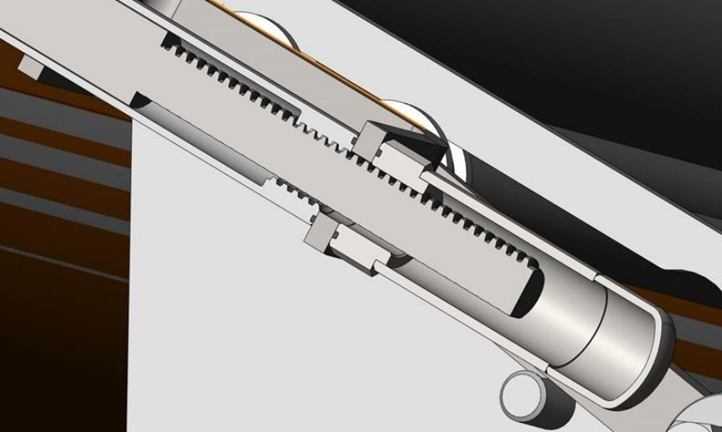
Figure 18 – Section view of sealed take-up
Figure 17 - Sealed take-up system

Conveyor Bed

Removable and tool-less conveyor bed shall be used unless approved by GMI. (See Fig. 19)
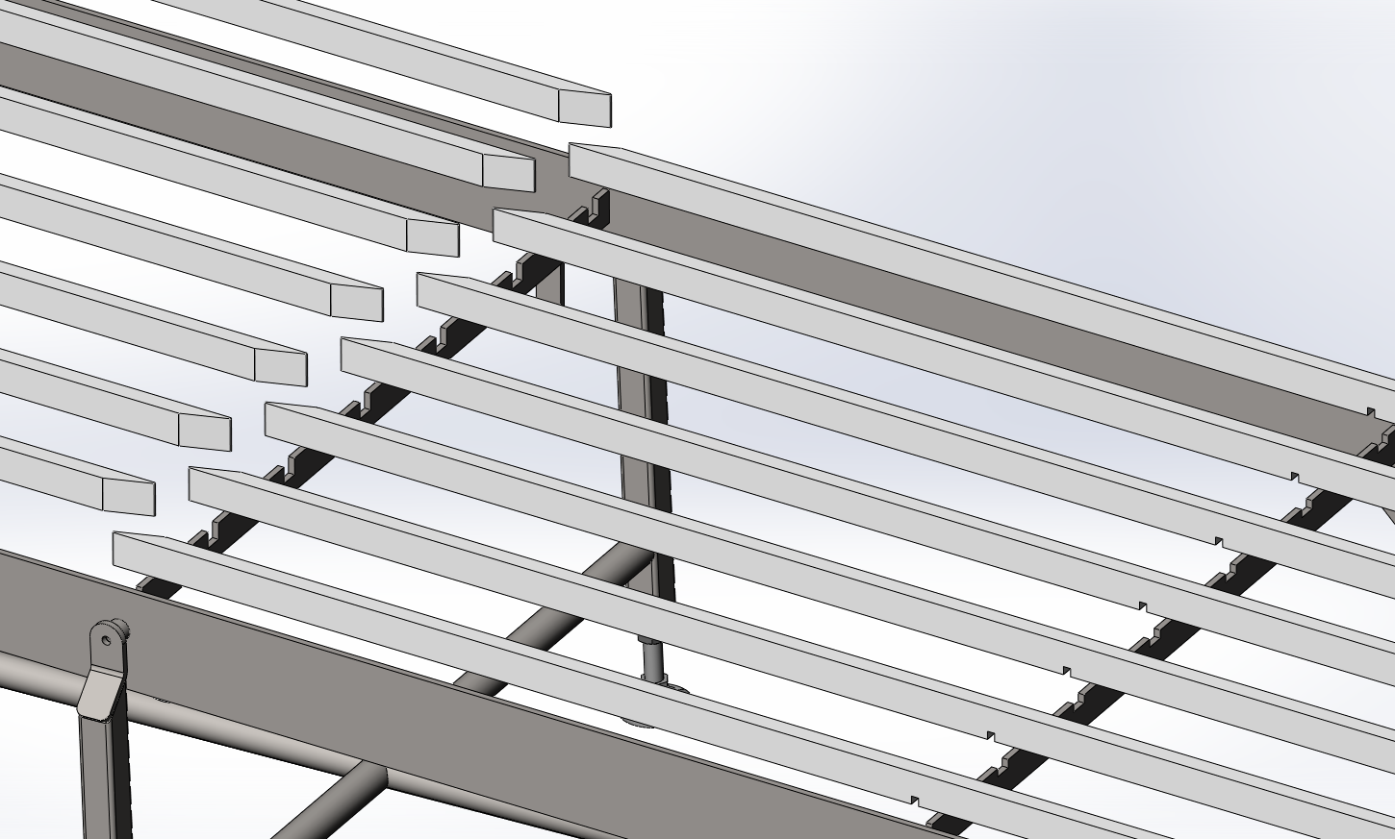
Figure 19 - Conveyor bed has tool-less lift out parts for easy cleaning

Belt Trackers

Belt trackers need to be of a sanitary design that allows for easy removal and cleaning.
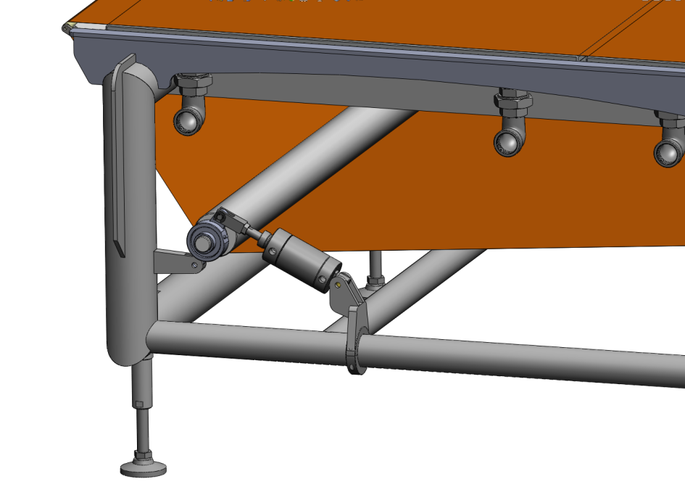
Figure 20 – Example of a single roll belt tracker

Doors or panels

Doors and panels need to be large enough to accommodate cleaning, maintenance, and inspection.

For hinge styles see section 5.21

Gaskets and seals shall be solid not hollow, and can be removed for cleaning.
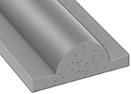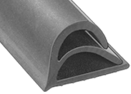
Figure 21 – gasket on the left is acceptable style and right gasket is not acceptable

Product & Side Guides

Conveyor side guides shall be a sanitary design and lifted for easy access and cleaning as shown in Fig. 22.

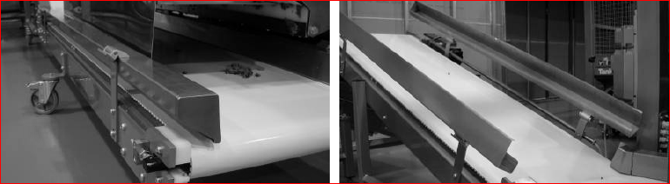
Figure 22

Clearance

Static conveyor frames should be designed to be installed with a free clearance of at least 12” above the floor. This should also account for any utility piping that may violate the 12” clearance. (Refer to section 6, Reference No. 1)

Surface Treatments or Coatings

All threaded holes and polished surfaces shall be protected. Surface coatings shall be free of flaking, delamination, pitting, blistering, or distortion when exposed to its intended environment. USDA/FDA approvals or letters from vendors certifying that it meets or exceeds past USDA/FDA guidelines for acceptance are acceptable. (Refer to section 6, Reference No. 1 & 3)

Bead blast requirements are as follows
- Shall not be used in product contact areas.
- Blast media shall conform to MIL-PRF-9954B, #12, (media diameter .0041-.0025).
- Recycled media can only have been used on the same series of stainless steel.
- Shall be done in a manner that does not warp or distort.

Teflon Release shall meet the requirements of:
- NEDOX SF-2, 0.0003”-0.0005” thick, vendor General Magnaplate,
- NI 428, 0.0003”-0.0005” thick, vendor Avtek
- Teflon S #959-023, 0.0003”-0.0005” thick, vendor Coating Solutions.
- All drawing dimension to apply after coating.

Anodizing shall meet the requirements of MIL-A-8625F, Type III, Class 1 (natural color) 0.002” thick, and protect threaded holes. All drawing dimensions to apply after coating.

Electropolish shall be equivalent to 4µin Rα finish and meet the requirements of ASTM-B912.

Passivation shall meet the requirements of ASTM-A967, Chemical Passivation Treatments for Stainless Steel Parts, ASTM-A380, and Standard Practice for Cleaning, Descaling, and Passivation of Stainless Steel Parts, Equipment and Systems. Federal Specification QQ-P-35C, Passivation Treatments for Corrosion Resistant Steels.

Conveyor Components

Conveyor Belts

Conveyor belt material to be non-absorbent, non-toxic and FDA approved.

Belts having product contact are required to be endless, exposed stitching or alligator clips are not acceptable.

Bearings

All bearings shall be sealed for life unless approve by GMI. (Approved manufactures can be found in Schedule W Machine Component Guideline)

Bearings should be located away from the product contact areas. If required near the product contact area, the materials shall be FDA-approved. (Refer to section 6, Reference No. 1)

If greased bearings are used and located above or in product contact areas a drip pan is requirement to protect from any leaks. Drip pan drains shall not be located over a product zone.

Motors/Gearboxes

Motors, gearboxes, and guards shall not be located above or in product contact areas. If located near product contact areas, the motors, gearboxes, and guards should be protected with a drip pan to capture any leaks or spills. Drip pan drains shall not be located over a product zone. (Refer to section 6, Reference No. 1)

Motors and gearboxes shall be wash-down rated, and also require a local motor disconnect unless approved by GMI.

Gear oil required to be food grade Category “A” unless approved prior by GMI. (See section 5.21.2)

Casters

Casters shall be of sufficient size, easily cleanable, durable, and will permit easy movement of the equipment.

Example of a commonly used rigid caster would be Colson® part number 4.06108.331 SS, and swivel caster 4.06109.331 SS BRK2, 6” Phenolic wheel with Delrin® bearing with and without brake. (Approved manufactures: Colson®, Hamilton®)

Fasteners

Series 300 Stainless Steel – All fasteners shall be types 18-8 (fasteners only), 304, 304L, 316 or 316L, depending upon the application. The application should be reviewed with GMI to determine the proper grade of stainless steel. The application may dictate the use of a specific grade of stainless steel, such as salt content, sanitation chemicals, etc. Type 303 stainless steel should not be used due to poor corrosion characteristics, even though it has lower machining and welding costs than 304 and 316. (Refer to section 6, Reference No. 1)

Series 400 Stainless Steel - Can be used in dry applications for nuts, bolts, metal screens, scrapers, knives, belt lacing (if this type of lacing is required), etc., due to the inherent strength and magnetic properties. Series 400 does not have the same corrosion resistance of Series 300. (Refer to section 6, Reference No. 1)

Approved fastener locking methods are to use Loctite®, Nord-lock®, Spiralock®, and Nylok in accordance to manufactures torque specifications. Split lock washers are not an acceptable fastener locking method.

Socket head style screws shall not be used unless they are away from product contact surfaces, and are shielded from product.

Rivets, Cadmium plated fasteners, sheet metal screws, self-tapping screws, staples, shall not be used unless approved by GMI.

Hinges

Hinges shall be AISI 300 series stainless steel lift-off or bolt on type for cleaning. Piano hinges are not allowed.
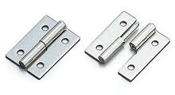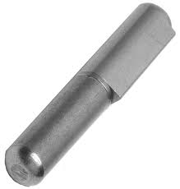
Figure 23 – bolted lift off style on left and weld lift off style on right

Seals

Shaft seals in product contact areas shall be non-absorbent, non-toxic, non-exuding, and odorless. Mechanical seals are preferred. (Refer to section 6, Reference No. 1)

Lubrication

The equipment vendor shall use the approved lubricants used in the particular GMI destination plant. (Refer to section 6, Reference No. 1)

Lubricants used in food environments can potentially contaminate food. With this in mind, GMI divides all lubricants into three (3) categories, which are: “A” or industry class H1, “B” or industry class H2, and “C” or industry class H3. (Refer to section 6, Reference No. 1)

Category “A” which is usually defined in industry as H1 is for lubricants with incidental food contact, or where under routine equipment usage the food may come in contact with the lubricant. All lubricants used in product zones or capable of incidental contact with food product shall be FDA-approved food-grade lubricants. All anti-seize lubricants (i.e. Never-seez) shall be FDA-approved food-grade material.

Category “B” which are usually defined in industry as H2 have a zero tolerance in food products. Non-food-grade/non-toxic lubricants may be used in areas that do not have the possibility of incidental food contact.

Category “C” which are usually defined in industry as H3 are toxic lubricants which shall not be used in a food processing plant unless they have been specifically approved for a well-defined use by the Quality & Regulatory Operations (QRO) personnel.

Gearboxes are not approved shipping containers, per the US Department of Transportation. The gearboxes shall be drained and tagged as being empty. It is the responsibility of the project team to verify that the equipment is properly lubricated prior to operation. (Refer to section 6, Reference No. 1) Sealed for life gearboxes will need to ship with the MSDS sheet provided by the manufacturer.

Mounting Feet

Sanitary stainless-steel mounting feet with enclosed threads shall be used on all floor contacts. Attachment methods to frame should be fully welded or bolted. Avoid holes in the feet if equipment is not going to be bolted to the floor. For approved suppliers visit: www.stainlessfeet.com (see fig. 24) or https://www.pfi-global.com/ (see fig. 25)
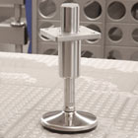
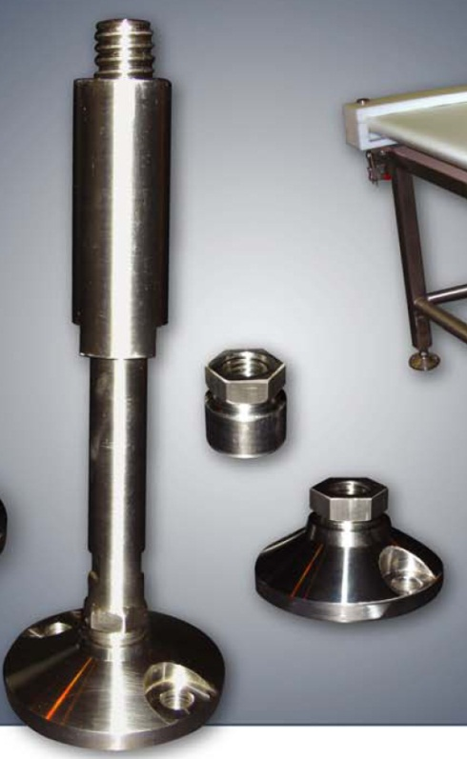
Figure 24 - NGI hygienic mounting feet
Figure 25 – PFI hygienic mounting feet

Hoods

If hoods are required they shall cover the open product area entirely, but not inhibit operator access to product or to clean.

Reference Documents
The following documents were used in constructing this standard:
- General Mills Sanitary Design Guidelines
- American National Standard for Baking Equipment – Sanitation Standard – 2003
- 3-A Sanitary Standard for Belt-type feeders, Number 75-01 www.3-a.org
- AWS/ANSI D18.1 – Specification for Welding of Austenitic Stainless Steel tube a Pipe Systems in Sanitary (hygienic) Applications. www.aws.org
- EHEDG Doc.9 – Welding Stainless Steel to Meet Hygienic Requirements. European Hygienic Equipment Design Group. www.ehedg.org
- EHEDG Guideline 2, A Method for Assessing the In-place Cleanability of Food Processing Equipment. European Hygienic Equipment Design Group. www.ehedg.org
- The Code of Federal Regulations (CFR), Title 21, Parts 175 – Indirect Food Additives: Adhesives and Components of Coatings. www.gpoaccess.gov/cfr/index.html
- General Mills Safety Guard Design Standard – US
- AWS D1.1: Workmanship & Acceptable Weld Profile Standards. Published by American Welding Society, 550 N.W. LeJeune Rd., Miami FL, Phone: (800) 443-3953 www.aws.org
- Aerospace Standard (AS) 568, Aerospace Size Standards for O-rings. www.sae.org
- ISO 3601-1:2002: Fluid Power Systems, Sealing Devices – O-Rings – Part 1: Inside diameters, cross-sections, tolerances and size identification code. www.iso.org
- ASTM International, www.astm.org

Revision Summaries
Enter information in these tables to track revisions to the master document.
NOTE: In the Entry column, enter your information between the dashes. The entries automatically update matching document properties.
Document Property | Entry
Master Owner | -Chris Crosby- | Increment revision numbers by one.
Master Revision Number | -3- | Increment revision numbers by one.
Master Revision Date | -07/29/2019- | Increment revision numbers by one.

Revision Number | Revision Date | Revision Owner | Revision Summary  (Brief description of major changes)
0 | 05/01/2013 | Chris Crosby | Original Development, Tom Fishlove, Bruce Button, Karl Thorson
1 | 02/07/2018 | Chris Crosby | Added links for schedule W, Z and OEM electrical & controls guidelines
2 | 10/09/2018 | Chris Crosby | Removed links to documents REV 1  Kofab now is named PFI
3 | 07/29/2019 | Chris Crosby | Added Thermolace, page 5 and 7 additions,  Added Conveyor Guidance, changed file name and now storing on Engineering Guidelines share point

Document location

Document location
https://genmills.sharepoint.com/sites/eng/req/Engineering%20Guidelines/Forms/AllItems.aspx

