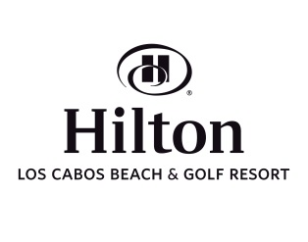
PRIVATE TRANSPORTATION
Hilton Los Cabos care as much about your arrival experiences as every other detail of your vacation in Los Cabos.
Let us facilitate your arrival by booking in advance a transfer from the airport to the hotel.

For your convenience we utilize Cadillac Escalade for your private transportation, this luxury service includes onboard complimentary wireless internet, bottle of water and welcome drink of your choice. The Escalade seats up to six passengers comfortably with luggage. Upon making your private reservation please indicate if you require an infant or toddler car seat.
Your transportation service will be charged directly to your room account for your own convenience.
Our prices:
Transportation service (One Way) 135 USD not including 16% sales tax, for 1 to 6 passengers
Transportation service (Round trip) 250 USD not including 16% sales tax, for 1 to 6 passengers
Gratuity: The rates stated above do not include gratuity, customary gratuities in Cabo are 15%

Please provide us the following information to schedule your transportation:

Full name: Departure Date:

Hotel Confirmation: Airline:

Celular Phone #: Flight Number :

E- mail address: Departure Time:

Arrival Date:

Airline:

Flight Number:

Arrival Time:

Number of Party:
Number of Luggage:

Due to Federal vehicle licensing laws in Los Cabos private transportation must be reserved at least 48 hours prior to your arrival
We also offer private transportation to your favorite restaurant, for more information please feel free to contact us.
San Jose del Cabo / $145 USD round trip plus 16% sales tax, up to 3 hours service, for 1 to 6 passengers
Cabo San Lucas /$150 USD round trip plus 16% sales tax, up to 3 hours service, for 1 to 6 passengers
Every extra hour of service / $55 USD plus 16% sales tax

We will send transportation confirmation details as soon as possible, please do not hesitate to contact us if you need further assistance.

