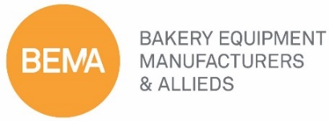
Association Outreach & Engagement
March 1, 2020
Chicago Hilton
AGENDA
Mike Day, Clay Miller, Mark Podl

- Call to Order Mike Day
- Welcome and Introductions Mike Day

- Committee Clay Miller
  - Overview/Update
  - Standing Committee Members

- Industry Show & Associations
  - Shows and Events Mark Podl
  - Associations Clay Miller
  - Trade Show Survey Kerwin Brown

- Action Items Kerwin Brown
- Assign Trade Shows
- Schedule Standing Committee Call
- Adjournment Mike Day

