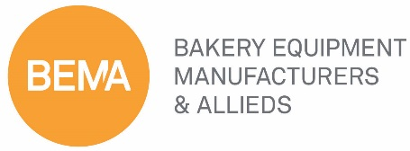

BEMA Standing Committee
Membership Value & Engagement Committee Meeting
Thursday, October 29th, 2020
Virtual Session
12:00 Noon CST

AGENDA
Mike Pierce, Jason Ward, Delia Justable

- Call to Order Mike Pierce, Committee Chair

- Action Items Update Kelly Allen, Membership Manager
- Virtual Roundtables Update
  - Safety and Sanitation Delia Justable, Co-Moderator
  - Sales Professionals Bruce Cox, Co-Moderator
  - Marketing and Tradeshows Kelly Allen Staff Liaison
  - C-Suite Mike Pierce, Co-Moderator
  - Human Resources Kelly Allen Staff Liaison
  - MemberSuite Report Kelly Allen, Membership Manager
    - Membership Directory
  - BEMA Index Jason Ward, Committee Vice Chair

- Membership Update Kelly Allen, Membership Manager
- Member recruitment during a pandemic
- 2020 Membership drops

- New Business
- Adjourn Mike Pierce, Committee Chair

Mission: BEMA connects, educates, and provide resources for its members and the industry they
serve.

Vision: BEMA creates an overwhelming competitive advantage for our members.

